The Strange Truth Behind Presidential Turkey Pardons

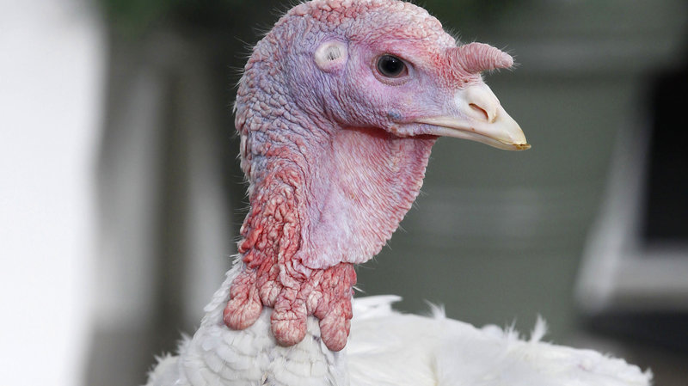

Liberty, a 45-pound turkey, is seen at the White House before being pardoned in 2011. The bird died two years later due to heart failure.

**Editor's note: This story was originally posted last year. Some information was updated on Nov. 22, 2016.**

The annual presidential turkey pardoning event at the White House is a strange one. This year is President Obama's eighth and last one, but he still seems confused.

"It is a little puzzling that I do this every year," Obama said in 2014.

"I know some folks think this tradition is a little silly," he said a year later. "I do not disagree."

The president has made the event something of an annual dad joke.

"Time flies, even if turkeys don't," Obama said last year, flanked by his daughters Sasha and Malia. There was a long pause and eventual polite laughter from his daughters and audience. "You think it's funny, too, don't you?" the president said to the crowd.

Introducing Tater and Tot, the 2016 National [#Thanksgiving](https://twitter.com/hashtag/Thanksgiving?src=hash) Turkeys: <https://t.co/wTcdWKlWAM>[#WHTurkeyPardon](https://twitter.com/hashtag/WHTurkeyPardon?src=hash) [pic.twitter.com/H3NjsU6YNT](https://t.co/H3NjsU6YNT)

— The White House (@WhiteHouse) [November 22, 2016](https://twitter.com/WhiteHouse/status/801112319229067265)

The turkeys always have punny names. Last year's were "Honest" and "Abe." The year before that "Mac" and "Cheese." This year — "Tater" and "Tot." But despite proclamations（正式的公告） of how the birds will live out their golden years in splendor, the joke... might be on the turkeys. They don't live very long after pardoning. (More on that below.)

There's always lots of laughter for a lighthearted moment the day before Thanksgiving, but the truth behind turkey pardons is a strange and sad tale with a long and myth-filled history.

So who are these overstuffed fowl? Where did they come from? And how did this whole thing get started, anyway? We try to answer those questions, and more:

**1. Where did they find these turkeys?**

This year's birds, "Tater" and "Tot," come from a farm in Storm Lake, Iowa, run by Chris and Nicole Domino. The family has been growing turkeys for nine years and raise about 185,000 a year, according to the [Kansas City Star](http://www.kansascity.com/news/nation-world/national/article114983303.html).

Both birds will be spared, but just one will stand for the official pardoning. That bird is [chosen in a White House contest](https://www.whitehouse.gov/blog/2016/11/22/president-obama-final-turkey-pardon).

These birds were separated from the flock and raised in a white building with red trim and Americana bunting（顶撞）. The turkeys will only be about four-and-a-half months old when they get to the White House.

The birds, selected from about 20, even went through podium（乐队指挥台，讲坛） practice to test their temperament（气质，性情）.

**2. Do they always get the turkeys from the same place?**

No. This is an event run by the National Turkey Federation. Yes, even turkeys have lobbyists（游说者）. (They have offices four blocks from the White House.)

The group is so involved in the event that it even pays for the turkeys to take a presidential-style motorcade from the farm to the airport flanked by fake Secret Service agents.

The men in dark suits with earpieces（耳筒，耳塞） are all part of the show, as are faux（人造的） presidential decals（贴花纸） depicting a turkey wearing a pilgrim（朝圣者） hat at the center of the "Seal of the National Turkey of the United States."

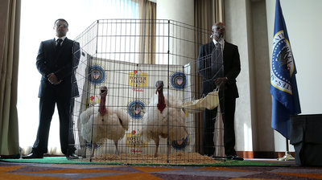

Men dressed as Secret Service agents stand guard next to Tom One and Tom Two, the 2015 turkey and alternate.

*Justin Sullivan/Getty Images*

**3. When and why did this begin?**

This whole thing got started in 1947 when Harry Truman was president. And that has actually been a source of confusion. Bill Clinton in his 1997 pardoning ceremony proclaimed that Truman was the first to pardon a turkey. But that's not true. The Truman Library issued a statement in 2003 saying:

"The Library's staff has found no documents, speeches, newspaper clippings, photographs, or other contemporary records in our holdings which refer to Truman pardoning a turkey that he received as a gift in 1947, or at any other time during his Presidency. ... Truman sometimes indicated to reporters that the turkeys he received were destined for the family dinner table."

So, Truman was the [first to receive](http://www.eatturkey.com/why-turkey/history) a ceremonial turkey from the National Turkey Federation (and the Poultry and Egg National Board), but he ate it (as did Eisenhower). And that was the intention of the gift — to raise the profile of the bird and maintain its institutionalization（制度化，体制化） as a Thanksgiving and Christmas staple.

The tradition of giving turkeys to the president goes much further back, though, than industry groups' involvement.

From 1873 to 1913, a turkey dealer from Rhode Island named Horace Vose, known as the "Poultry King," became the unofficial turkey provider to the White House for Thanksgiving and Christmas, according to the [White House Historical Society](http://www.whitehousehistory.org/pardoning-the-thanksgiving-turkey).

In 1913, Vose got some competition from a former Kentucky congressman, who claimed his bird tasted better, because it was fed a diet of red peppers. After Vose died in 1913, it was something of a free for all.

**4. OK, so if it wasn't Truman, then who was the first to pardon a turkey?**

It depends on your definition of "pardon."

An [1865 dispatch](http://www.whitehousehistory.org/questions/which-president-started-the-tradition-of-pardoning-the-thanksgiving-turkey) from White House reporter Noah Brooks is the oldest-known account of a presidential turkey clemency（仁慈，温和，宽厚）. It was about **Abraham Lincoln** sparing a bird two years earlier. It was a Christmas turkey that his son Tad had taken a liking to.

**John F. Kennedy** appears to have been the first to pardon a *Thanksgiving* turkey.

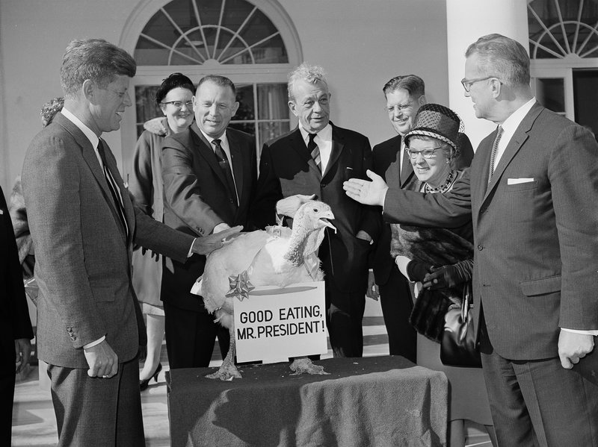

President John F. Kennedy reaches out to touch a 40-pound turkey at the White House in 1963. The presentation was made on behalf of the nation's turkey industry.

*Harvey Georges/AP*

"We'll just let this one grow," he said.

The *LA Times* headlined that 1963 event as a "[presidential pardon](http://www.nbcnews.com/news/other/presidential-turkey-pardons-not-long-history-you-might-think-f2D11663410)," but a sign hung around the turkey's neck that read, "Good eating, Mr. President." The intention, at least from the giver, was clear.

**Richard Nixon** also chose not to eat one particular bird and sent it to a petting zoo instead.

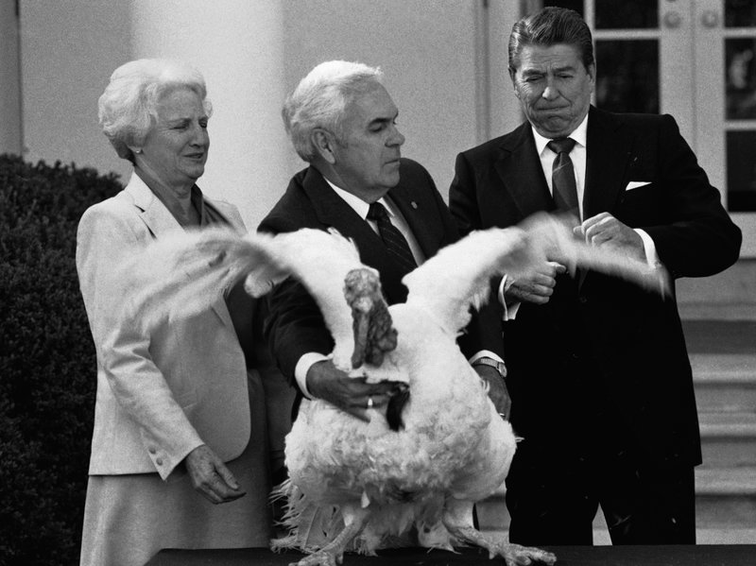

President Ronald Reagan is startled as John Hendrick (center), president of the National Turkey Federation, presents him with a turkey in 1984.

*Scott Stewart/AP*

**Ronald Reagan** in 1987 was technically the first president to use the word "pardon" about a turkey, but it was really just a way to deflect questions about the Iran-Contra scandal and whether he would pardon key players involved — Oliver North and John Poindexter.

The bird, "Charlie," was already headed for a petting zoo, but after Sam Donaldson of ABC News pressed Reagan on whether he'd pardon North and Poindexter, Reagan [responded](http://www.reagan.utexas.edu/archives/speeches/1987/112387d.htm), "If they'd given me a different answer on Charlie and his future, I would have pardoned him."

The president who formalized（使正式，使有效，使定型，使拘泥于形式） the event was**George H.W. Bush**,giving birth to the modern-day tradition.

**5. What happens to the turkey afterward?**

This is where the story turns very sad.

This year's turkeys will be sent to Virginia Tech, where, the White House says, "they will be cared for by veterinarians and students of Virginia Tech's Animal and Poultry Sciences Department at 'Gobbler's（狼吞虎咽的人） Rest' in Blacksburg, Virginia."

The turkeys got to meet the Hokie （吉祥物）, where the Turkey Federation joked in a tweet that "these new buds will be hanging out together at their new home after" the pardon.

But probably not for long.

The average lifespan of a turkey in the wild is only [three to four years](http://animals.nationalgeographic.com/animals/birds/wild-turkey/), but these birds, because they are bred to be eaten, have lived on average far less than that.

Many industrially grown turkeys are fattened up with a [protein-rich diet of corn and soybeans](http://minnesotaturkey.com/turkeys/fun-facts/). They can't fly, because they are too big; their bone structures can't hold up all that weight for very long; and their organs fail if they're kept alive too long.

Every pardoned turkey is dead except three, who are only at this point presumedalive... 2014's "Cheese" and 2015's "Honest" and "Abe."

"Cheese," the second half of 2014's duo ("Mac" died in July 2015, just eight months after pardoning) was reportedly still alive, as of November of last year. Morven Park in Virginia, where the birds were sent, touted（被吹捧的） "presidentially pardoned" turkeys (plural（复数）) to visit, perhaps including 2015's "Honest" and "Abe," though these haven't been confirmed by NPR.

The outlier in all this was "Courage," the first bird pardoned by Obama in 2009. In 2015, Courage had been reported dead by other outlets, but Disneyland, where the bird was sent, contacted NPR to let us know the fowl was still kicking.

We reached out this year about "Courage's" status. And, sadly, Disneyland confirmed that "Courage" has died.

Courage passed earlier this year," Suzi Brown, a Disneyland spokeswoman told NPR.

Living six-plus years might be some kind of record set by Courage. Disneyland has a theory.

"Because he was under our care and fed a balanced diet," Brown told NPR, "he slimmed down quite a bit and lived quite a healthy life here at the resort."

The unfortunate reality for these turkeys has been a sore point for animal-rights activists, like People for the Ethical Treatment of Animals, better known as PETA, which listed its complaints, including [noting the fates](http://www.peta.org/features/white-house-turkey-pardon/) of the recent "pardoned" birds.

Others, including writers at the Washington Post and Vox, have called the pardon "[America's dumbest](https://www.washingtonpost.com/news/wonk/wp/2013/11/26/the-turkey-pardon-is-americas-dumbest-tradition/)" and "[most absurd holiday tradition](http://www.vox.com/2014/11/24/7276353/white-house-turkey-pardon)."

The turkey federation, of course, pushes back on the notion that the event is an arcane（神秘的，晦涩难解的） one that has seen it's time come and go.

"Think of the meaning of Thanksgiving," Keith Williams, vice president for communications and marketing at the turkey federation, argued to NPR in 2015. "It's always been about the presentation of the National Thanksgiving Turkey — symbolic of the blessings of agriculture we have in this country. It becomes a time for the president to recall with the nation our blessings and celebrate the beginning of the holiday season."

**6. Why do presidents pardon turkeys? Don't they eat turkey at Thanksgiving?**

That irony may account for Obama's puzzlement. He also joked in 2014 that he was saving those turkeys from a "terrible and delicious fate."

People are full of contradictions.

It's clearly been difficult for politicians to say on camera that they would eat the bird presented to them, especially as America has grown away from an agricultural society and grown up with Disney movies heavy on the personification of animals. Americans are far more removed from the actual process of how their food makes its way to their table.

"Your grandmother (1940s) would have killed her own and prepared it," Keith Williams of the turkey foundation noted. "Since the 1950s, it became more convenient for families to have the dressed turkeys (all ready to cook), which they bought from the butcher or their grocery store. Few people actually hunt and dress their own food — we thankfully have the farmers who grow and deliver food to us."

Side fact: The turkey federation actually provides dressed turkeys to presidents, too. Obama has donated his.

The turkey federation seems potentially open to a return to the days when presidents ate the turkeys presented to them.

"The pardoning was a recent custom begun with President George H.W. Bush," Williams noted.

Some traditions are hard to change.

It's something to think about after you walk through the grocery store, pick out that turkey — and sit down at the Thanksgiving dinner table.

<http://www.npr.org/2015/11/25/457253194/the-strange-truth-behind-presidential-turkey-pardons>

译文：  
总统赦免火鸡背后的奇怪真相

在2011年被赦免前，一只45磅重的火鸡“自由”出现在白宫。两年后，这只鸟死于心脏衰竭。

编者按:这篇文章最初发表于去年。部分信息更新于2016年11月22日。

每年在白宫举行的总统火鸡赦免活动很奇怪。今年是奥巴马总统第八个也是最后一个任期，但他似乎仍然很困惑。

2014年，奥巴马曾说:“我每年都这么做，这有点令人费解。”

“我知道有些人认为这个传统有点傻，”一年后他说。“我不反对。”

总统把这个活动变成了一年一度的老爸笑话。

去年，奥巴马在两个女儿萨莎和玛利亚的陪伴下说:“时间过得真快，即使火鸡活不下去。”沉默了很久，他的女儿和观众终于礼貌地笑了起来。“你们也认为这很有趣，是吗?”总统对人群说。

介绍2016年全国感恩节火鸡# Tater and Tot: https://t.co/wTcdWKlWAM#WHTurkeyPardon pic.twitter.com/H3NjsU6YNT

-白宫(@WhiteHouse) 2016年11月22日

火鸡都有双关语的名字。去年的是"诚实"和"亚伯"前年那个"通心粉"和"奶酪"今年是"土豆泥"和"土豆泥"尽管公告(正式的公告)鸟类将如何度过他们的黄金年辉煌,笑话…可能在火鸡上。他们被赦免后活不了多久。(下面有更多相关内容。)

感恩节前一天总是会有很多欢乐的时刻，但火鸡赦免背后的真相是一个奇怪而悲伤的故事，有着漫长而充满神话的历史。

这些肥头大耳的鸡是谁?它们是从哪里来的?这整件事是怎么开始的?我们试图回答这些问题，甚至更多:

1. 他们在哪里找到这些火鸡的?

今年的火鸡“Tater”和“Tot”来自爱荷华州Storm Lake的一个农场，由Chris和Nicole Domino经营。据《堪萨斯城星报》报道，这家人养火鸡已经九年了，每年大约能养18.5万只火鸡。

两只鸟都将幸免，但只有一只将代表官方赦免。那只鸟是在白宫竞赛中选出来的。

这些鸟是分开的羊群和成长在一个白色建筑装饰红色和美国旗帜(顶撞)。这两只火鸡入住白宫时只有四个半月大。

鸟,从大约20个选择,甚至经历了讲台(乐队指挥台,讲坛)实践测试他们的气质(气质,性情)。

2. 他们总是从同一个地方买火鸡吗?

不。这是由国家火鸡联盟举办的活动。是的,甚至火鸡说客(游说者)。(他们的办公室距离白宫四个街区。)

该组织对这一活动的参与程度如此之高，以至于他们甚至出钱让火鸡乘坐总统风格的车队从农场前往机场，并由冒牌的特勤局特工陪同。

身着深色西装与耳机(耳筒,耳塞)都显示的一部分,是假的(人造的)总统贴标(贴花纸)描绘了一个戴着朝圣者的土耳其(朝圣者)帽子的中心美国国家火鸡的“海豹”。

打扮成特勤局特工的男子在2015年的火鸡“汤姆一号”和“汤姆二号”旁边站岗。

贾斯汀沙利文/盖蒂图片社

3.这是什么时候，为什么开始的?

这一切始于1947年哈里·杜鲁门任总统时。这实际上是一个困惑的来源。比尔·克林顿在1997年的赦免仪式上宣布，杜鲁门是第一个赦免火鸡的人。但事实并非如此。杜鲁门图书馆在2003年发表声明说:

图书馆的工作人员在我们的馆藏中没有发现任何文件、演讲、剪报、照片或其他当代记录，涉及杜鲁门在1947年或他任内任何时候赦免他作为礼物收到的一只火鸡. ...杜鲁门有时向记者表示，他收到的火鸡是要上家庭餐桌的。

所以，杜鲁门是第一个从国家火鸡联盟(以及家禽和鸡蛋国家委员会)得到仪式火鸡的人，但他吃了它(艾森豪威尔也是这样做的)。这是礼物的目的——提高鸟的形象和保持其制度化(制度化,体制化)作为感恩节和圣诞节的主食。

然而，将火鸡送给总统的传统要追溯到更早的时候，而不是行业团体的参与。

据白宫历史协会(White House Historical Society)称，从1873年到1913年，罗德岛(Rhode Island)有一位名叫霍勒斯·沃斯(Horace Vose)的火鸡经销商，人称“家禽大王”，他成为白宫感恩节和圣诞节的非官方火鸡供应商。

1913年，一名肯塔基州的前国会议员与沃斯竞争，他声称他的火鸡味道更好，因为它吃了红辣椒。在沃斯于1913年去世后，这是一个对所有人都免费的地方。

4. 好吧，如果不是杜鲁门，那谁是第一个赦免火鸡的人?

这取决于你对"赦免"的定义

1865调度从白宫记者诺亚布鲁克斯是目前所知最古老的土耳其总统赦免(仁慈,温和,宽厚)。是关于亚伯拉罕·林肯两年前救了一只鸟。那是他儿子泰德很喜欢的圣诞火鸡。

约翰·肯尼迪似乎是第一个在感恩节赦免火鸡的人。

1963年，约翰·肯尼迪总统在白宫伸手去摸一只40磅重的火鸡。这个演示是代表国家的火鸡产业做的。

哈维乔治/美联社

“我们就让这棵继续长吧，”他说。

《洛杉矶时报》把1963年的那次事件作为“总统赦免”的标题，但火鸡的脖子上挂着一个牌子，上面写着:“总统先生，吃得好。”至少赠与人的意图是很清楚的。

理查德·尼克松也选择不吃某只鸟，而是把它送到了宠物动物园。

1984年，美国火鸡联合会主席约翰•亨德里克(中间)向里根总统赠送火鸡时，里根总统大吃一惊。

斯科特·斯图尔特/美联社

严格来说，罗纳德·里根在1987年是第一个用“赦免”这个词来形容火鸡的总统，但这实际上只是为了转移人们对伊朗门丑闻以及他是否会赦免其中关键人物奥利弗·诺斯和约翰·波因德克斯特的疑问。

这只名叫“查理”的鸟已经被送往宠物动物园，但在ABC新闻的山姆·唐纳森追问里根是否会原谅诺斯和波因德克斯特后，里根回答说，“如果他们对查理和他的未来给我一个不同的答案，我就会原谅他。”

正式的总统(使正式,使有效,使定型,使拘泥于形式)事件是乔治·布什,生的现代传统。

5. 之后火鸡会怎么样?

这就是故事变得非常悲伤的地方。

今年的火鸡将被发送到弗吉尼亚理工大学,在那里,白宫说,“他们将由兽医和弗吉尼亚理工大学的学生照顾动物和家禽科学学系狼吞虎咽的(狼吞虎咽的人)剩下的布莱克斯堡,弗吉尼亚。”

火鸡要满足Hokie(吉祥物),在火鸡联盟在推特开玩笑说,“这些新的花蕾将一起闲逛在他们的新家园”的原谅。

但可能不会持续太久。

野生火鸡的平均寿命只有三到四年，但这些鸟，因为它们是为了食用而繁殖的，平均寿命远低于这一水平。

许多工业化饲养的火鸡都是用富含蛋白质的玉米和大豆喂养的。它们不能飞，因为它们太大了;它们的骨骼结构承受不了那么长时间的重量;如果存活时间过长，他们的器官就会衰竭。

每只被赦免的火鸡都死了，除了三只，它们在这一点上被认为是活着的……2014年的“Cheese”，2015年的“Honest”和“Abe”。

据报道，2014年二人组的下半部分“奶酪”(“Mac”在2015年7月去世，仅在赦免8个月后)截至去年11月仍活着。Morven公园在弗吉尼亚州,鸟类被吹捧(被吹捧的)“总统赦免火鸡(复数(复数)),也许包括2015年的“诚实”和“安”,尽管这些没有被美国国家公共电台证实。

这一切中的异类是“勇气”，它是奥巴马在2009年赦免的第一只鸟。2015年，其他媒体报道了勇气的死亡，但这只鸟被送往的迪士尼乐园联系了美国国家公共电台，告诉我们这只鸟还在踢着。

我们今年联系了"勇气"的地位。不幸的是，迪斯尼乐园证实了“勇气”已经死了。

勇气在今年早些时候消失了，”迪斯尼乐园女发言人苏西·布朗告诉美国国家公共电台。

活了6年多可能是勇气创造的某种记录。迪斯尼乐园有一个理论。

“因为他在我们的照顾下，饮食均衡，”布朗告诉美国国家公共电台(NPR)，“他瘦了不少，在度假胜地过着相当健康的生活。”

这些火鸡的不幸遭遇一直是动物权利活动人士的痛处，比如善待动物组织(People for The Ethical Treatment of Animals，简称PETA)，他们列出了自己的抱怨，包括指出了最近这些“被赦免”的火鸡的命运。

其他人，包括《华盛顿邮报》(Washington Post)和Vox的撰稿人，称赦免是“美国最愚蠢的”和“最荒谬的节日传统”。

火鸡联盟,当然,推动事件是一个神秘的概念(神秘的,晦涩难解的)一个,来来去去的时候了。

“想想感恩节的意义，”火鸡联合会负责传播和营销的副总裁基思·威廉姆斯(Keith Williams) 2015年对美国国家公共电台(NPR)说。“这一直是为了展示国家感恩节火鸡，象征着我们国家农业的幸福。这是总统和全国人民一起缅怀我们的祝福，庆祝假期开始的时刻。”

6. 为什么总统要赦免火鸡?他们在感恩节不吃火鸡吗?

这种讽刺可能解释了奥巴马的困惑。2014年，他还开玩笑说，他是在把这些火鸡从“可怕而美味的命运”中拯救出来。

人是充满矛盾的。

很明显，政客们很难在镜头前说他们会吃掉送给他们的鸟，尤其是美国已经远离了农业社会，成长于迪斯尼电影中大量拟人化动物的时代。美国人对他们的食物是如何送到他们的餐桌上的这个实际过程远远不感兴趣。

火鸡基金会的基思•威廉姆斯说:“你的祖母(上世纪40年代)可能会亲手宰杀自己的火鸡来做火鸡。”自20世纪50年代以来，家家都可以更方便地从肉店或杂货店买到准备好了的火鸡。很少有人真的自己狩猎和加工食物，谢天谢地，我们有农民种植并运送食物给我们。”

附带事实:火鸡联盟实际上也会向总统们提供盛装的火鸡。奥巴马捐了他的钱。

火鸡联盟似乎愿意回到总统吃火鸡的时代。

“赦免是乔治·h·w·布什总统最近开始的一个习俗，”威廉姆斯说。

有些传统是很难改变的。

当你走过杂货店，挑出那只火鸡，并坐在感恩节餐桌前时，这是一件值得思考的事情。